Adroit Power – Executive Sales Dashboard
Tabs
Tab | Dashboard Name | Audience
🟩 1 | Today’s Overview & Alerts | Owner + Sales Head
🟧 2 | Weekly Tracker & Lead Funnel | Owner + Sales Head
🟦 3 | Monthly & Quarterly Growth | Owner
🟨 4 | Individual KPI Dashboard | Admins + Sales Head
🟪 5 | Executive Command Dashboard | Owner

🟩 TAB 1: Today’s Overview & Alerts (Real-Time Sales Pulse)
Purpose: Single screen to show what’s happening today and what’s not done.
🧾 Top KPIs (Tiles)
KPI | Description
🧭 New Leads (All Sources) | IndiaMART, Justdial, Cold Calls, Referrals
🧾 Quotations Created Today | Total sent by both admins
📞 Follow-Ups Done vs Pending | Discipline indicator
💼 Orders Confirmed Today | Successful closures
💰 Payments Received Today | Cash inflow
🕒 Pre-Visits Pending | Awaiting service team scheduling

⚠️ Critical Alerts (Dynamic Red Panel)
Alert | Trigger
🔔 Quotations pending follow-up > 3 days | Lost touch with leads
🔔 IndiaMART / Justdial leads not contacted in 24 hrs | Missed new enquiry
🔔 Orders pending pre-visit / service > 3 days | Service delay
🔔 Payments overdue > 15 days | Collection lag
🔔 Customers inactive > 30 days | No interaction
⚡ Note: Auto email these alerts to you + Sales Head every morning.
Example:
- ⚠️ 4 IndiaMART leads pending quotation for >2 days.
- 🟢 Quotations increased by 12% this month, conversion steady at 27%.
- 🔴 Pre-visit backlog increasing — service response delay 3.8 days.
- 🟢 Admin 2 fastest follow-up turnaround (1.2 days).
- 🔴 Top lost reason: Price competition (40%).
📊 Follow-Up Health (Sales Discipline Section)
Metric | Description | Visual
✅ Follow-Ups Done Within 1 Day | Speed gauge (Target: 90%) | Speedometer
⏳ Quotations With No Follow-Up | Uncontacted quotes | Red counter
📤 Quotations Waiting for Sending (>1 day) | Admin delay | Alert badge
⚠️ Overdue Follow-Ups | Missed schedule | Red indicator

📉 Day wise Rolling View
Metric | Day 1 | Day 2 | Day 3 | Day 4 | Day 5 | Weekly  Total
Quotations Sent | 5 | 4 | 6 | 4 | 6 | 15
Follow-Ups Done | 2 | 3 | 4 | 3 | 4 | 9
Orders Confirmed | 1 | 2 | 1 | 2 | 1 | 4
Quotations Without Follow-Up | 3 | 2 | 3 | 2 | 3 | 8

📊 Order Lost Analysis (Suitable Chart)
Reasons: Postponed, Too Far, Service Not Possible, Transport, Price
→ Helps track avoidable losses.
Order Lost analysis : Cost wise, Post Pone, Far away place, Design pending etc
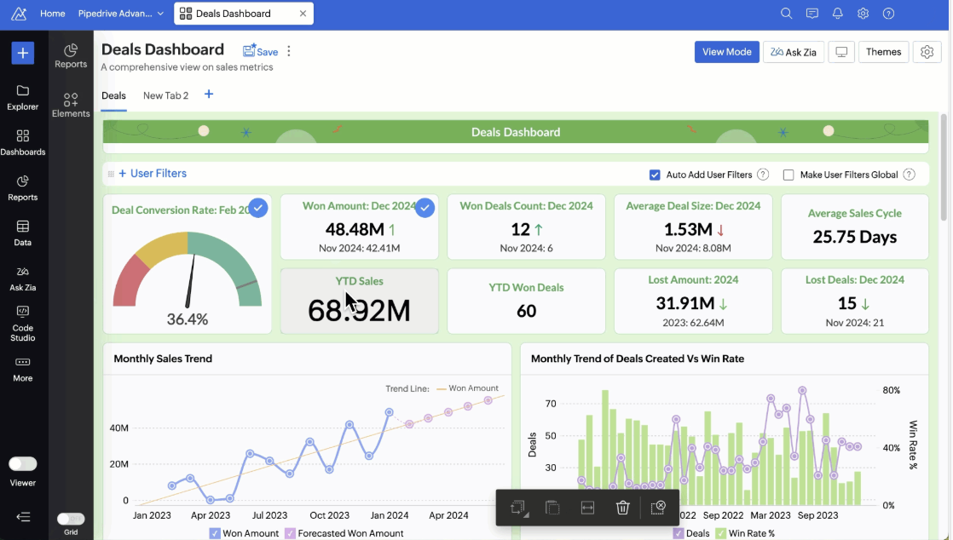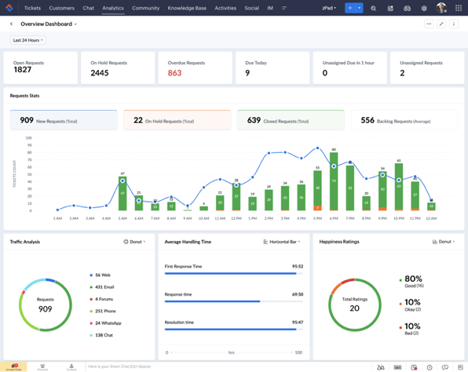

🟧 TAB 2: Weekly Tracker & Lead Conversion (Sales Funnel + Source + Service)
Purpose: Weekly trend, lead source quality, pre-visit responsiveness.
📈 Weekly KPI Highlights
Metric | Current Week | Last Week | Change
New Leads | 42 | 38 | +10%
Quotations Sent | 38 | 36 | +5%
Orders Confirmed | 10 | 9 | +11%
Payments Received (₹) | ₹4.5L | ₹4.2L | +8%
Follow-Ups Missed | 7 | 5 | 🔴 +2
Pre-Visits Pending | 4 | 3 | 🔴 +1

🔄 Sales Funnel (End-to-End)
Lead → Quotation → Follow-Up → Order → Payment
Stage | Count | Conversion %
Leads | 150 | —
Quotations Sent | 120 | 80%
Follow-Ups Done | 90 | 75%
Orders Confirmed | 40 | 44%
Payments Received | 30 | 75%
(Visual Funnel Chart)
Weekly – Upcoming Client funnel
📞 Lead Source & Conversion Breakdown
Pie or Horizontal Bar Chart:
- IndiaMART
- Justdial
- Cold Calls
- Existing Customers
- Referrals
- Dealers / OEM
(Number of leads, conversion %)
Extra KPIs:
- 🆕 “New Dealers Added This Month”
- ⏱ “Leads Awaiting Contact” count

🧰 Pre-Visit & Service Coordination
Metric | Visualization
Pre-Visit Requests vs Completed | Bar chart
Average Delay (Days) | KPI counter
Pending >3 Days | Table (Customer, Product, Age)
Feedback After Visit (%) | Gauge
Automation: Alert to service team & you when pending >3 days.
🧰 Customer Satisfaction
Customer rating collected through zoho CRM
Complaints list if any
Customer Expectation collected through zoho CRM

🟦 TAB 3: Monthly & Quarterly Business Performance (Growth Dashboard)
Purpose: Understand business growth, margin, and productivity.
💹 Monthly Summary Tiles
Metric
Total Quotations (count)
Orders Confirmed (count)
Conversion Rate(%)
Revenue (₹)
Profit (₹)
Expenses (₹)
Lost Orders (₹ + Count)
Avg Order Value (₹)
Graphs
- Monthly Sales Revenue Trend (Line Chart) – Compare Current vs Previous Year
- Quotation vs Order per Month (Clustered Bar)
- Sales vs Cost vs Profit (3-Line Chart)
- Last 4 Quarters Sales (Bar)
- Order Lost Reasons (Stacked Bar by Quarter)
- YOY Growth (Line or Column)
- Top Performing Quarter (Highlight)
🧩 Benchmark & Targets
Target has to be set by respective person every month beginning based on the monthly meeting, rise an alert for the same
Metric | Target | Actual | Status
Yearly Growth | +40% | +32% | 🟡
Dealer Appointments | 2/month | 1 | 🔴
Lost Orders Reduction | 10%/quarter | 8% | 🟢
Referrals from Customers | 2/month | 1 | 🔴
Customer Reviews (Google/Mail/Letter) | 2/month | 3 | 🟢

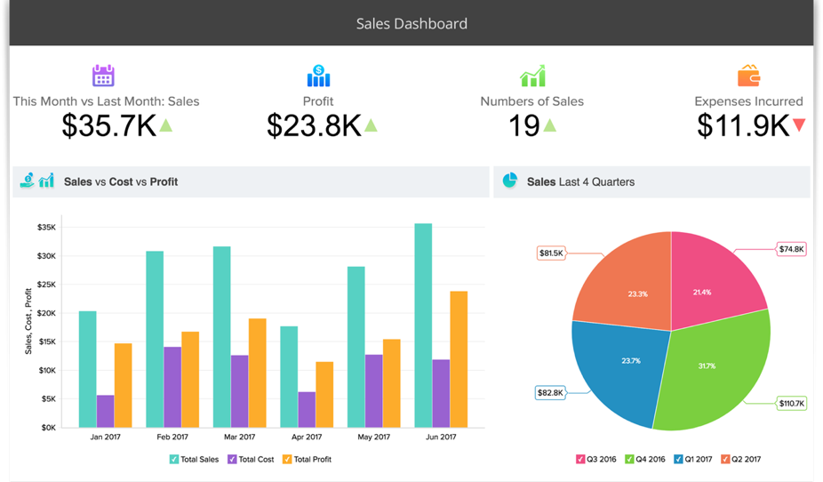
Monthly Customer Satisfaction
Graph of rating
Complaints list if any
Competitors Detail (Separate Entry- Done by service engineers, ) - List it down

🟨 TAB 4: Individual KPI (Role-Specific Dashboard)
👩‍💻 Admin KPI Dashboard (admin 1 sales, admin 2 sales)
KPI | Description | Visualization
Quotations Created | Count/day | Counter
Avg. Quote Delay (hrs/days) | Lead → Quote time | Trend line
Leads from IndiaMART / Justdial attended | Count | Bar
Quotations Followed Up | Done vs Pending | Donut
Missed Calls or Unattended Leads | Count | Alert
Payment Sale order payment delay
Accuracy of Quote (Approved vs Revised)  (Accuracy score has to be given by MD and Sales head) so add the field for the same | % | Gauge
Customer Feedback/ Satisfaction (how many did each one many collect?)
Sample
Name | Quotations Sent | Avg No of Follow-ups done per customer | Conversion Rate | Delay in Sending Quote (Days)
Admin 1 | 8 | 5 | 28% | 2.1
Admin 2 | 7 | 6 | 35% | 1.3

👨‍💼 KPI Dashboard Comparison (for Sales Head & MD sir)
KPI | Description | Visualization
New Leads Generated | Cold Calls, Referrals, OEM, Dealer | Bar
Quotations Approved | Count | KPI
Follow-Ups Done | Frequency | Line
Orders Closed | Count + ₹ | KPI
Conversion Rate | Quotations → Orders | Gauge
Pre-Visits Coordinated | Count | KPI
Customer Visits / Meetings | Count | KPI
Customer Feedback/ Satisfaction (how many did each one many collect?) | Count | KPI
Lead Response Delay (Days) | From Admin to Action | Trend line

👑 Combined KPI of Sales Dept
Metric | Shows
Admin Efficiency | Quote creation, response speed
Sales Effectiveness | Conversion %, Follow-up rate
Lead Quality | Source-wise performance
Profit Margin | Sales vs cost trend
Growth | YOY & quarter-on-quarter

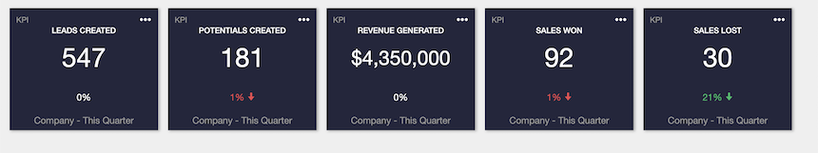
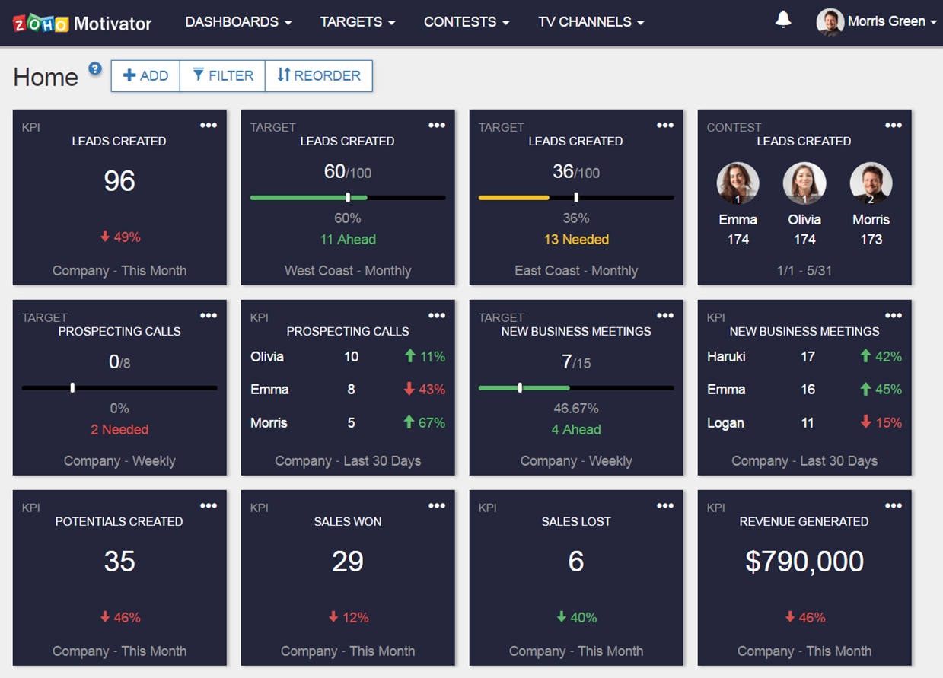

🟪 TAB 5: Executive Command View (Overall)
Purpose: Owner’s single-screen control center
Top KPIs Tiles
- Total Revenue (₹)
- Conversion Rate (%)
- Outstanding Payments (₹)
- Lost Orders %
- Customer Growth (New vs Repeat)
- Regional Sales Map
- Top performing quarter
Graphs
- Monthly Sales Revenue
- Conversion Trend vs Lost trend (Line graph)
- Orders vs Payments
- Top Customers & Products
- Alerts Summary
- Funnel Overview
- YOY Growth Chart
- ABC customer revenue chart
Customer & Market Growth Insights
Chart | Insight
📈 Top 10 Customers (by Sales Value) | Key accounts contribution
💸 Top 5 Lost Orders (Value) | Missed high-value opportunities
🧭 Sales by Region / City (Map) | Growth areas & potential expansions
🔄 Repeat vs New Customers (Donut Chart) | Business stability vs new growth

⚙️ Automations (for All Tabs)
- Follow-Up Reminder: Auto task if not done within 24 hrs
- Uncontacted Lead Alert: Flag to Sales Head if >1 day
- Pre-Visit Delay: Alert if >3 days pending
- Weekly Summary Email: Monday morning → PDF snapshot to Director

To be added in the field:
- How many customer feedbacks have been collected by each? – proof attached as screenshot
- Order Lost Analysis – Cost, Postpone, Faraway place cant service, Transportation problem.
- Upcoming Client Entry (for next month)
- Customer satisfaction
- ABC customer chart listing
- Marketing Analysis Competitor Detail – entered by service engineers, sales head
- Sale order payment delay

